Worldwide CF Samples AnalysEs

Contents
Worldwide CF Samples Analysis 1
Contents 1
Methods 2
Results 2
Complete 2
PRJNA316588 2
PRJNA1081394 3
PRJNA516442 4
PRJEB20836 5
PRJNA1126024 6
PRJNA510441 7
PRJEB14440 10
PRJNA1055940 10
PRJEB32062 13
PRJNA644285 14
PRJNA931830 15
Mixed Results 15
PRJNA1101448 15
PRJEB51171 17
Analysis Failed 20
PRJNA71831 20
PRJEB54014 20
Awaiting Further Data 21
PRJNA615628 - Hahn 21
PRJNA825831 - Hahn 21
PRJNA846291 - Hahn 21
PRJNA839435 22
Unpublished Data 22
PRJNA516870 22
PRJNA1091195 23
PRJNA316056 23
References 24

Methods
Samples were identified by searching the SRA using NCBI and Google’s BigQuery. First, the NCBI SRA was searched for any BioProject with the phrase “Cystic Fibrosis” (available at https://www.ncbi.nlm.nih.gov/bioproject/?term=cystic+fibrosis). In February 2025, this resulted in 1,187 bioproject IDs. Next, the SRA metadata was queried using Google’s BigQuery. First, we build a temporary table that contains all entries where either the assay type is “AMPLICON” or the library selection is “PCR”. Next, we selected the entries in the SRA metadata where the library source is “METAGENOMIC” or ‘METATRANSCRIPTOMIC’, or the organism contains “microbiom” or “metagenom” (to find microbiome/microbiomics or metagenome/metagenomics and other variants). We cross-referenced the bioprojects from this list with those from the SRA search for “Cystic Fibrosis” and excluded any BioProjects that were entirely based on amplicon sequencing. Finally, we filtered the dataset for the “organism” field to contain one or more of the following entries: human lung metagenome; metagenome; human sputum metagenome; Homo sapiens; human nasopharyngeal metagenome; lung metagenome; human metagenome; mixed culture metagenome; clinical metagenome; or respiratory tract metagenome. The last filtering step largely (but not entirely) eliminates the gut microbiome samples. Individual fastq files were downloaded using Kingfisher (Woodcroft et al. 2024), and then each run was processed using the atavide-lite pipeline (Edwards 2025), as previously described. Data was imported into Jupyter notebooks available on GitHub for processing and analysis.

Results

Complete

PRJNA316588
Project Title: Sputum Metagenome Of CF, COPD, Smokers And Healthy Subjects (Feigelman et al. 2017).

The entire data set consists of 18 runs, totalling 121,257,187,412 bp. We analysed 17 metagenomic sequence runs that passed QC. We predicted that two samples out of 17 (11.8%) were likely to be Pseudomonas culture positive.
Summary
Runs analysed: 17
Runs correctly predicted: 17

We correctly predicted the culturability of Pseudomonas in all the samples in this study.

Table S2 of that paper presents this data:
Patient ID | SRR | Clinically detected bacteria | Pseudomonas prediction
CF-99_2 | SRR5110496 | Staphylococcus aureus | Negative
CF-99 | SRR5110005 | Staphylococcus aureus | Negative
CF-76 | SRR5109959 | Pseudomonas aeruginosa | Positive
CF-85 | SRR5109913 | Achromobacter xylosoxidans; Staphylococcus aureus | Negative
CF-82 | SRR5109957 | Pseudomonas aeruginosa | Positive
CF-94 | SRR5109960 | Staphylococcus aureus | Negative
CF-00 | SRR5109961 | Stenotrophomonas maltophilia; Haemophilus influenzae | Negative

PRJNA1081394
Project title: Pseudomonas aeruginosa. Sinus, throat, and sputum airway microbiology in cystic fibrosis. (Hilliam et al. 2024; Armbruster et al. 2024). Note: These papers report 16S sequencing and some aspects of the metagenomics, but they have not yet detailed all the metagenomics. Need to check with the CIs about publishing.
Armbruster et al. is a longitudinal study of airway microbiota and P. aeruginosa population genomics in pwCF, including samples taken before and after initiation of CFTR modulator therapy (Armbruster et al. 2024). However, most of these sequences are amplicon sequencing, and the remainder are essentially P. aeruginosa samples. The entire data set is 549 runs, and 510,156,291,748 bp (including amplicon sequences). We analysed 330 metagenomic sequence runs. We predicted that 310 samples out of 330 (93.9%) were likely to be Pseudomonas culture positive, and 20 were not.
Summary
Runs analysed: 330
Runs correctly predicted: 311

The study looked at the effect of ETI on Pseudomonas colonisation in pwCF. In the published study, they show that Pseudomonas remains detectable by 16S amplicon sequencing in all but one of the seven samples reported, but at much lower numbers. There was no evidence that the negative samples were collected later (e.g. post-ETI) or from a specific sample (throat vs. sputum vs. sinus), and so without further metadata, we cannot explain those negative samples. We conclude that probably one of the 20 should be negative, and the others should be positive.

PRJNA516442
Project title: Depletion of human DNA from complex clinical samples for metagenomic sequencing (Nelson et al. 2019).
Note these are Steve Stick’s samples, so we can always ask him!

The entire data set is 93 runs, and 34,371,719,753 bp (including amplicon sequences). We analysed 15 metagenomic sequence runs and predicted that eight samples (53.3%) were likely to be Pseudomonas culture positive. We correctly predicted all of these, with the caveat described below.
Summary
Runs analysed: 15
Runs correctly predicted: 15

Table. Summary of the samples and our predictions from BioProject PRJNA516442.
Run | Sample name | Prediction | Probability | Confidence
SRR8731680 | 185 Standard | + | 0.70 | ++
SRR8731681 | 184 Benzonase1 | + | 0.68 | ++
SRR8731682 | 183 Molysis | - | 0.74 | ++
SRR8731683 | 184 Standard | + | 0.66 | ++
SRR8731684 | 183 Benzonase1 | - | 0.66 | ++
SRR8731685 | 185 Benzonase1 | + | 0.66 | ++
SRR8731686 | 184 Antibody Depletion | + | 0.65 | ++
SRR8731687 | 183 Standard | - | 0.62 | ++
SRR8731688 | 185 Antibody Depletion | + | 0.72 | ++
SRR8731689 | 183 Antibody Depletion | - | 0.65 | ++
SRR8731690 | 184 Molysis | - | 0.65 | ++
SRR8731691 | 185 Cell Lysis | + | 0.59 | +
SRR8731692 | 184 Cell Lysis | + | 0.63 | ++
SRR8731693 | 185 Molysis | - | 0.79 | ++
SRR8731694 | 183 Cell Lysis | - | 0.54 | +

We find that 5 (out of 7) negative culturability predictions are from sample 183, from which they could not culture Pseudomonas, so those are correct. We predict that all of the Molysis cultures will be negative. In their paper, they note that they did observe a large decrease in P. aeruginosa relative abundance in the Molysis-treated samples (Nelson et al. 2019). Thus, although 184 Molysis and 185 Molysis are the wrong predictions, they match those from the publication.
Note: Out of the runs, only 33 are >100bp (the others have an average length of 91bp). Of those 33, 18 are 16S sequences, leaving only 15 runs that are long enough to be analysed and that are not 16S runs.

PRJEB20836
Project title: Cystic fibrosis pathogens (Weimann et al. 2024)
This dataset contains individual isolate genomes from both pwCF and non-CF individuals.

According to the SRA metadata, they sequenced
54 Mycobacteroides abscessus
Summary
Runs analysed: 8
Runs correctly predicted: 8
1 Pseudoalteromonas atlantica
1,341 Pseudomonas aeruginosa

However, our results do not match this at all, and I can not connect the supplemental data in the Science paper with the metadata from SRA.
For example, the supplemental data lists 9,837 SRA/ENA run IDs, but only eight of those match the metadata in this project.
Furthermore, I contacted the first author (Dr. Aaron Weimann) about a couple of the IDs that are reported to be Pseudomonas in the metadata (e.g. ERR11682986 or ERR11683307). These samples seem to be about 50% human DNA, 25% S. aureus, and only a little bit (<1%) Pseudomonas. Our analysis does not match the description in the paper. Dr Weimann said that those samples were not part of his study, and it is not known where they came from.
I can only conclude that we correctly identified eight Pseudomonas pure isolates that are likely to culture Pseudomonas, but at this stage, we cannot say anything about the other 1,342 “metagenomics” runs we analysed.

PRJNA1126024
Project title: Shotgun metagenomic data from bronchoalveolar lavage fluid (BALF) samples of infants with CF (Agudelo-Romero et al. 2025, 2024).
Summary
Runs analysed: 2
Runs correctly predicted: 2

The entire data set consists of 2 runs, totalling 1,071,033,642 bp. We analysed two metagenomic sequence runs and predicted that one of those samples (50.0%) was likely to be Pseudomonas culture positive.
It is not quite clear what these samples are. The SRA metadata suggests that one may be Staphylococcus aureus, but it also says it is BALF. The PCA below shows that one is similar to a positive sample, and the other is not.
In Agudelo-Romero 2025, they isolate five Pseudomonas phage genomes from SRR29521294, which we correctly predict is likely to harbour culturable Pseudomonas. In Agudelo-Romero 2024, they isolate a Staphylococcus phage from SRR29469209.

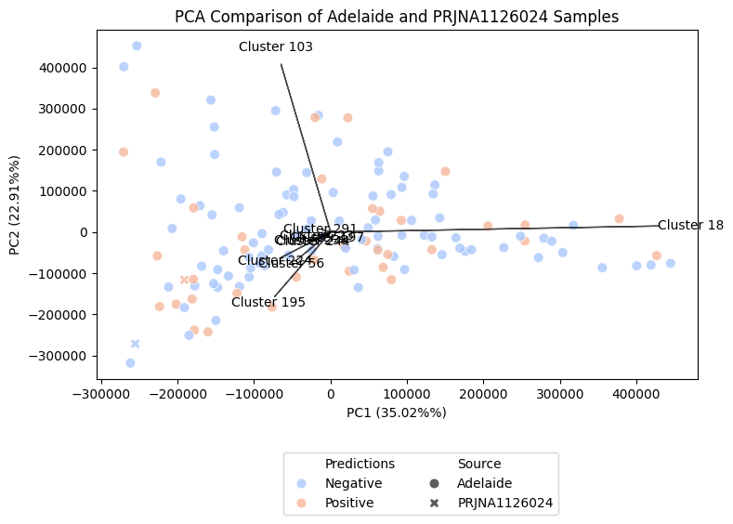

PRJNA510441
Project Title: Time series of patients with cystic fibrosis (Cobián Güemes et al. 2019).
Summary
Runs analysed: 14
Runs correctly predicted: 5
The entire data set consists of 14 runs, totalling 906,511,907 bp. We analysed 14 metagenomic sequence runs. We predicted that five samples out of 14 (35.7%) were likely to be Pseudomonas culture positive. However, the metadata below suggests that this pwCF had Pseudomonas throughout the sampling.

We reached out to Ana Cobian, and she confirmed, “We ran those reads with a 300 bp kit, using 300 bp for one end. The reads were filtered with Prinseq, which allowed us to cut the sequences based on quality scores; this is why some of them are shorter than 300 bp.
What we uploaded to NCBI are the reads after quality filtering (prinseq) and after human genome removal. We uploaded 12 metagenomes and two metatranscriptomes.”

Table. Read length distribution and average read length of raw sequences in the PRJNA510441 library. Red shading: incorrectly predicted Pseudomonas culturability. Green shading: correctly predicted Pseudomonas culturability.
File | Reads | Shortest | Longest | Average length
SRR8334087 | 110,796 | 60 | 300 | 265.49
SRR8334088 | 222,183 | 60 | 300 | 270.74
SRR8334089 | 125,289 | 60 | 300 | 271.65
SRR8334090 | 119,257 | 60 | 300 | 242.57
SRR8334091 | 5,178 | 60 | 300 | 231.05
SRR8334092 | 130,640 | 60 | 300 | 273.17
SRR8334093 | 338,707 | 56 | 100 | 99.33
SRR8334094 | 47,158 | 60 | 300 | 266.76
SRR8334095 | 15,932 | 70 | 250 | 242.18
SRR8334096 | 20,191 | 70 | 250 | 242.99
SRR8334097 | 2,234,958 | 35 | 151 | 147.79
SRR8334098 | 2,010,467 | 35 | 151 | 147.34
SRR8334099 | 99,187 | 60 | 300 | 260.09
SRR8334100 | 36,650 | 60 | 300 | 265.82

Table. Summary of the clinical data from Supplemental Table 1c in (Cobián Güemes et al. 2019), amended with our predictions.
Day | Status† | Bacteria | Fungi | SRA Run ID | Original Sample ID | Predictions | Score | Confidence
724 |  |  |  | SRR 8334088 | CF01 mg D724 | - | 0.5 | +
723 |  |  |  | SRR 8334087 | CF01 mg D723 | - | 0.69 | ++
722 |  |  |  | SRR 8334090 | CF01 mg D722 | + | 0.7 | ++
721 |  |  |  | SRR 8334089 | CF01 mg D721 | + | 0.67 | ++
720 |  |  |  | SRR 8334100 | CF01 mg D720 | + | 0.62 | ++
719 | E | Pseudomonas aeruginosa, Pseudomonas fluorescens | Yeast, Aspergillus fumigatus | SRR 8334099 | CF01 mg D719 | + | 0.57 | +
718 |  |  |  | SRR 8334092 | CF01 mg D718 | - | 0.57 | +
674 | S | Pseudomonas aeruginosa
547 | S | Pseudomonas aeruginosa | Yeast
540 | S | Pseudomonas aeruginosa | Yeast
414 | S | Pseudomonas aeruginosa | Yeast
409 |  |  |  | SRR 8334091 | CF01 mg D409 | - | 0.69 | ++
373 | S | Pseudomonas aeruginosa | Yeast
286 |  |  |  | SRR 8334094 | CF01 mg D286 | - | 0.6 | +
279 |  |  |  | SRR 8334096 | CF01 Dmt 303 | - | 0.62 | ++
279 |  |  |  | SRR 8334095 | CF01 mt D279 | - | 0.63 | ++
204 | E | Pseudomonas aeruginosa, Stenotrophomonas maltophilia | Yeast
192 | E | Pseudomonas aeruginosa, Stenotrophomonas maltophilia | Yeast, Aspergillus terreus
48 | S | Pseudomonas aeruginosa, Stenotrophomonas maltophilia, Enterobacter cloacae | Yeast
24 | E | Pseudomonas aeruginosa, Enterobacter cloacae | Yeast
14 | E | Pseudomonas aeruginosa | Yeast
8 |  |  |  | SRR 8334098 | CF01 mt D8 | - | 0.51 | +
8 |  |  |  | SRR 8334093 | CF01 mg D8 | + | 0.66 | ++
7 | E | Pseudomonas aeruginosa, Stenotrophomonas maltophilia | Yeast | SRR 8334097 | CF01 mt D7 | - | 0.53 | +
1 | E | Pseudomonas aeruginosa, Stenotrophomonas maltophilia
0 | E | Pseudomonas aeruginosa, Stenotrophomonas maltophilia | Aspergillus terreus
†E: Exacerbation; S: Stable

We have a very mixed predictive capability here, which may be attributed to the low number of reads (e.g., SRR8334091 only has ~5,000 reads) and the use of single-end reads.

PRJEB14440
Project Title: Pseusomonas aeruginosa metagenomes (Sommer et al. 2016)

The entire data set consists of five runs, totalling 1,330,576,074 bp, and we correctly predicted that all of them would result in positive Pseudomonas cultures. These samples were from pwCF recently infected with Pseudomonas.
Summary
Runs analysed: 5
Runs correctly predicted: 5

PRJNA1055940
Project Title: Microbiome analysis in the respiratory tract of individuals with cystic fibrosis and non-cystic fibrosis bronchiectasis (Motta et al. 2024).
Summary
Runs analysed: 61
Runs correctly predicted: 45

The entire data set consists of 61 runs, totalling 386,942,064,540 bp. We analysed 61 metagenomic sequence runs. We predicted that nine samples out of 61 (14.8%) were likely to be Pseudomonas culture positive.
We correctly identified whether or not Pseudomonas would be cultured in 26/35 patients when compared to the culture reports listed in Table 2 in Motta et al. We consistently reported “false negatives”—patients from whom Pseudomonas had been cultured, but for whom we did not identify Pseudomonas in the sequences. Additionally, our results were always consistent between the induced sputum and nasopharyngeal swab samples within patients. However, Motta et al. reported significantly fewer reads that mapped to Pseudomonas in those samples than in the positive samples (Table). We hypothesise that at the time of sampling, these patients had very low levels of Pseudomonas colonisation.

Table. Summary of the number of reads reported by Motta et al. For correctly and incorrectly classified samples (no positive samples were incorrectly predicted)
Outcome | Pseudomonas Prediction | min | mean | max
Correct | Negative | 55 | 1,149 | 17,545
Correct | Positive | 9,049 | 175,019 | 553,062
Incorrect | Negative | 85 | 955 | 6,627
Incorrect | Positive | - | - | -

Table. Summary of all the reads.
Original ID | Type | Sample | Number of Pseudomonas reads reported in SOM | Cultured | Pseudomonas Prediction | Confidence | Certainty | Result | Reason
be 01 | is | SRR27326975 | 17,545 |  | - | 0.51 | + | ✓
be 01 | nps | SRR27326950 | 558 |  | - | 0.72 | ++ | ✓
be 02 | is | SRR27326974 | 55 |  | - | 0.81 | +++ | ✓
be 03 | is | SRR27326963 | 135,805 | Pa | + | 0.76 | ++ | ✓
be 03 | nps | SRR27326949 | 166,746 | Pa | + | 0.67 | ++ | ✓
be 04 | is | SRR27326952 | 52,813 | Pa | + | 0.62 | ++ | ✓
be 04 | nps | SRR27326948 | 9,049 | Pa | + | 0.55 | + | ✓
be 05 | is | SRR27326932 | 257 | Pa, Sa | - | 0.72 | ++ | ✘ | Low read abundance
be 05 | nps | SRR27326938 | 194 | Pa, Sa | - | 0.81 | +++ | ✘ | Low read abundance
be 06 | is | SRR27326921 | 85 | Pa, Sa | - | 0.74 | ++ | ✘ | Low read abundance
be 06 | nps | SRR27326937 | 147 | Pa, Sa | - | 0.67 | ++ | ✘ | Low read abundance
be 07 | is | SRR27326943 | 6,627 | Pa, Ac | - | 0.62 | ++ | ✘ | Marginal
be 07 | nps | SRR27326936 | 210 | Pa, Ac | - | 0.72 | ++ | ✘ | Low read abundance
be 08 | is | SRR27326941 | 261 | Pa | - | 0.7 | ++ | ✘ | Low read abundance
be 08 | nps | SRR27326935 | 173 | Pa | - | 0.75 | ++ | ✘ | Low read abundance
be 09 | is | SRR27326940 | 144 |  | - | 0.55 | + | ✓
be 09 | nps | SRR27326934 | 552 |  | - | 0.64 | ++ | ✓
be 10 | nps | SRR27326933 | 124 |  | - | 0.84 | Hig | ✓
cf 01 | is | SRR27326939 | 1,197 | Pa, Sa | - | 0.68 | ++ | ✘ | Low read abundance
cf 02 | is | SRR27326973 | 112 | Pa, Sa | - | 0.67 | ++ | ✘ | Low read abundance
cf 02 | nps | SRR27326930 | 198 | Pa, Sa | - | 0.7 | ++ | ✘ | Low read abundance
cf 03 | is | SRR27326972 | 553,062 | Pa, Sa | + | 0.8 | +++ | ✓
cf 04 | is | SRR27326971 | 59 |  | - | 0.79 | ++ | ✓
cf 04 | nps | SRR27326928 | 107 |  | - | 0.68 | ++ | ✓
cf 05 | is | SRR27326970 | 179,447 | Pa, Sa | + | 0.72 | ++ | ✓
cf 05 | nps | SRR27326927 | 61,591 | Pa, Sa | + | 0.53 | + | ✓
cf 06 | is | SRR27326969 | 2,451 | Pa, Sa, Bc | - | 0.51 | + | ✘ | Low read abundance
cf 06 | nps | SRR27326926 | 1,438 | Pa, Sa, Bc | - | 0.55 | + | ✘ | Low read abundance
cf 07 | is | SRR27326968 | 89 | Sa | - | 0.78 | ++ | ✓
cf 07 | nps | SRR27326925 | 5,302 | Sa | - | 0.54 | + | ✓
cf 08 | is | SRR27326967 | 1,270 | Pa, Bc | - | 0.7 | ++ | ✘ | Low read abundance
cf 08 | nps | SRR27326924 | 252 | Pa, Bc | - | 0.77 | ++ | ✘ | Low read abundance
cf 09 | is | SRR27326966 | 1,962 | Bc | - | 0.53 | + | ✓
cf 09 | nps | SRR27326923 | 250 | Bc | - | 0.76 | ++ | ✓
cf 10 | is | SRR27326965 | 303,849 | Pa | + | 0.67 | ++ | ✓
cf 10 | nps | SRR27326922 | 112,810 | Pa | + | 0.71 | ++ | ✓
cf 11 | is | SRR27326953 | 4,060 |  | - | 0.51 | + | ✓
cf 11 | nps | SRR27326942 | 374 |  | - | 0.55 | + | ✓
cf 12 | nps | SRR27326931 | 268 | Hi | - | 0.73 | ++ | ✓
cf 13 | nps | SRR27326929 | 414 | Pa, Sa | - | 0.61 | ++ | ✘ | Low read abundance
ht 01 | is | SRR27326964 | 1,795 |  | - | 0.54 | + | ✓
ht 01 | nps | SRR27326920 | 173 |  | - | 0.75 | ++ | ✓
ht 02 | is | SRR27326962 | 485 |  | - | 0.64 | ++ | ✓
ht 02 | nps | SRR27326919 | 162 |  | - | 0.72 | ++ | ✓
ht 03 | is | SRR27326961 | 216 |  | - | 0.72 | ++ | ✓
ht 04 | is | SRR27326960 | 135 |  | - | 0.72 | ++ | ✓
ht 04 | nps | SRR27326917 | 259 |  | - | 0.74 | ++ | ✓
ht 05 | is | SRR27326959 | 73 |  | - | 0.71 | ++ | ✓
ht 05 | nps | SRR27326916 | 480 |  | - | 0.62 | ++ | ✓
ht 06 | is | SRR27326958 | 100 |  | - | 0.73 | ++ | ✓
ht 06 | nps | SRR27326915 | 290 |  | - | 0.71 | ++ | ✓
ht 07 | is | SRR27326957 | 542 |  | - | 0.73 | ++ | ✓
ht 07 | nps | SRR27326947 | 125 |  | - | 0.8 | ++ | ✓
ht 08 | is | SRR27326956 | 367 |  | - | 0.7 | ++ | ✓
ht 08 | nps | SRR27326946 | 796 |  | - | 0.64 | ++ | ✓
ht 09 | is | SRR27326955 | 146 |  | - | 0.66 | ++ | ✓
ht 09 | nps | SRR27326945 | 352 |  | - | 0.65 | ++ | ✓
ht 10 | is | SRR27326954 | 568 |  | - | 0.61 | ++ | ✓
ht 10 | nps | SRR27326944 | 102 |  | - | 0.77 | ++ | ✓
ht 11 | is | SRR27326951 | 2,594 |  | - | 0.62 | ++ | ✓
ht 12 | nps | SRR27326918 | 139 |  | - | 0.71 | ++ | ✓
is: human induced sputum
nps: human nasopharyngeal swab
Pa: P. aeruginosa
Sa: S. aureus
Bc: B. cepacia
Hi: H. influenzae
Ac: Achromobacter sp.

PRJEB32062
Project Title: Lung Microbiome Dynamics in Cystic Fibrosis (Dmitrijeva et al. 2021; Mirhakkak et al. 2023)

The entire data set consists of 27 runs, totalling 113,773,728,053 bp. We analysed 25 metagenomic sequence runs and predicted that 16 samples (64.0%) were likely to be Pseudomonas culture positive.
Summary
Runs analysed: 25
Runs correctly predicted: 24

In (Dmitrijeva et al. 2021) they note that patient CFR06 is devoid of any Pseudomonas, and we did not predict that any of their samples would be culture positive for Pseudomonas. Our only incorrect prediction was sample SAMEA5554307 from CFR11, but I can’t connect that to the sample date in the metadata to compare to their outcomes.

Sample | Pseudomonas Prediction | Confidence | Certainty | pwCF ID | Correct Prediction
ERR3274613 | - | 0.60 | + | CFR06 | ✓
ERR3274614 | - | 0.80 | ++ | CFR06 | ✓
ERR3274615 | - | 0.67 | ++ | CFR06 | ✓
ERR3274616 | - | 0.75 | ++ | CFR06 | ✓
ERR3274617 | - | 0.77 | ++ | CFR06 | ✓
ERR3274618 | - | 0.77 | ++ | CFR06 | ✓
ERR3274619 | - | 0.78 | ++ | CFR06 | ✓
ERR3274620 | - | 0.77 | ++ | CFR06 | ✓
ERR3274621 | + | 0.71 | ++ | CFR07 | ✓
ERR3274622 | + | 0.72 | ++ | CFR07 | ✓
ERR3274623 | + | 0.69 | ++ | CFR07 | ✓
ERR3274624 | + | 0.78 | ++ | CFR09 | ✓
ERR3274625 | + | 0.78 | ++ | CFR09 | ✓
ERR3274626 | + | 0.71 | ++ | CFR09 | ✓
ERR3274627 | + | 0.73 | ++ | CFR09 | ✓
ERR3274628 | + | 0.63 | ++ | CFR11 | ✓
ERR3274629 | + | 0.66 | ++ | CFR11 | ✓
ERR3274630 | + | 0.62 | ++ | CFR11 | ✓
ERR3274631 | + | 0.56 | + | CFR11 | ✓
ERR3274632 | + | 0.55 | + | CFR11 | ✓
ERR3274633 | - | 0.66 | ++ | CFR11 | ✘
ERR3274634 | + | 0.63 | ++ | CFR11 | ✓
ERR3274635 | + | 0.61 | ++ | CFR11 | ✓
ERR3274636 | + | 0.62 | ++ | CFR11 | ✓
ERR3274637 | + | 0.70 | ++ | CFR11 | ✓

PRJNA644285
Project Title: Study of fungal clinical isolates from different anatomical sites and metagenomics of the lung microbiome of patients with cystic fibrosis (de Almeida et al. 2020).
Summary
Runs analysed: 12
Runs correctly predicted: 11

The entire data set is 12 runs, and 29,679,938,510 bp, and we analysed all the runs and
predicted that three samples (25.0%) were likely to be Pseudomonas culture positive.

Sample | pwCF | Clinical condition | Fev-01 | Culture | Antibiotic Therapy | Pseudomonas Prediction | Confidence | Certainty | Outcome
SRR12149839 | PA1 | Ex | 39% | Af, Sa, Pa, Bcc | C, T, A | - | 0.65 | ++ | ✘
SRR12149836 | PA2 | Ex |  | NI |  | - | 0.72 | ++ | ✓
SRR12149835 | PA3 | Am |  | Af, Bcc |  | - | 0.67 | ++ | ✓
SRR12149830 | PA4 | Ex |  | Af, Pe | M, V, G | - | 0.64 | ++ | ✓
SRR12149837 | PA5 | Am |  | Af, Td |  | - | 0.71 | ++ | ✓
SRR12149834 | PB1 | Ex | 64% | NI | Z, G | - | 0.71 | ++ | ✓
SRR12149829 | PB2 | Am |  | Ta, Td, Ha, Bcc |  | - | 0.69 | ++ | ✓
SRR12149838 | PB3 | Am |  | Ta |  | - | 0.56 | + | ✓
SRR12149840 | PC1 | Ex | 37% | Af, Ca, Ac | I | + | 0.59 | + | ✓
SRR12149833 | PC2 | Ex |  | Af, Pa, St | M, G | + | 0.59 | + | ✓
SRR12149832 | PC3 | Ex |  | Af, Ac, Ch |  | - | 0.53 | + | ✓
SRR12149831 | PC4 | Am |  | Af, Pa, Sa |  | + | 0.66 | ++ | ✓

Clinical Condition:  Ex: Exacerbation  Am: Ambulatory  Culture:  Ac: Achromobacter sp.  Af: A. fumigatus,  Bcc: Burkholderia. cepacia complex  Ca: Candida albicans  Ch: Chryseobacterium indologenes  Ha: Hanseniaspora sp.  Pa: P. aeruginosa  Pe: Penicillium sp.  Sa: S. aureus MRSA,  St: Stenotrophomonas maltophilia  Ta: Talaromyces sp.  Td: Torulaspora delbrueckii | Antibiotics/Antifungals:  A: Amoxi/Clav  C: Ciprofloxacin  G: Gentamycin  I: Itraconazole  M: Meropenem  T: Tobramycin  V: Vancomicin  Z: Ceftazidime

PRJNA931830
Project Title: The metagenome of children with cystic fibrosis (Mostacci et al. 2023).

The entire data set comprises 260 runs, totalling 740,690,138,100 bp. From these, we predicted that 12 samples (4.6%) were likely to be Pseudomonas culture positive.
Summary
Runs analysed: 260
Runs correctly predicted: 259
Table 1 in Mostacci et al. shows that 11 pwCF were culture positive. We have not figured out which prediction was incorrect, and they do not provide a table with individual samples.

Mixed Results

PRJNA1101448
Project Title: Longitudinal changes on the oropharyngeal metagenome among children with cystic fibrosis after ETI (Steinberg et al. 2025).
The entire data set is 323 runs, and 89,493,823,284 bp. We analysed all 323 metagenomic sequence runs, but did not predict that any of them were likely to be Pseudomonas culture positive.
Note that these samples were from oral swabs. In PRJEB51171 (below), which sampled both sputum and swabs, we were significantly worse at predicting outcomes with the swabs than with the sputum, so that is likely affecting our predictions here.

The t-SNE shows that their data is different from our data:
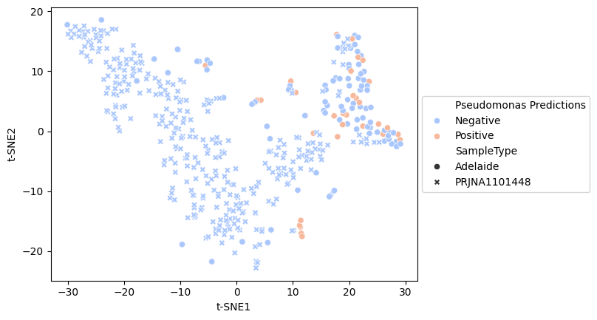
Fig. t-SNE of all the analysed sequence data coloured by whether culturing Pseudomonas is predicted, and shapes are based on the sample.

Two samples are close to our positive samples, and appear to be more likely to be able to culture Pseudomonas than the others:

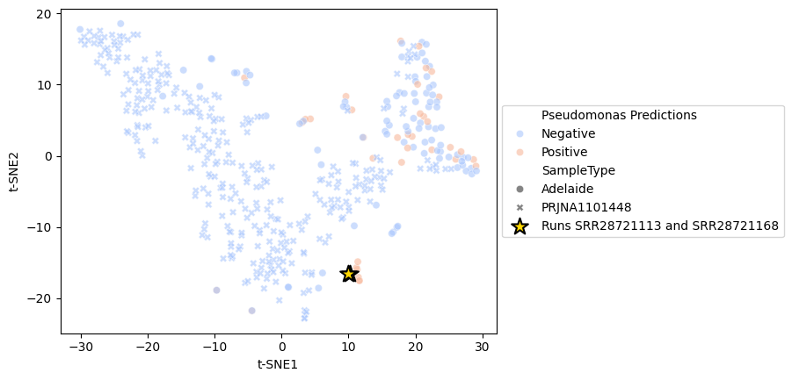
It is also intriguing because those Adelaide samples are all from the same person: 1128691_20171206_S, 1128691_20171218_S, and 1128691_20180116_S.

We can explain this difference using a waterfall plot (this is not a publication-quality image):
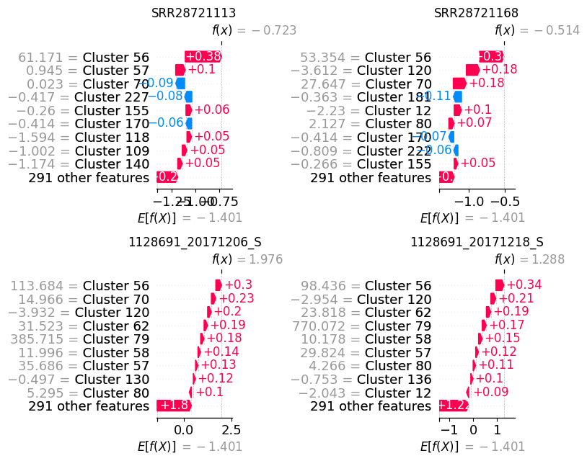
Fig. Shapley additive explanations (SHAP) waterfall plot of the four closely related samples. Note how SRR28721113 and SRR28721168 both have forces that are providing negative evidence (blue) while the positivity of the same clusters dominates 1128691_20171206_S and 1128691_20171218_S. The Gradient Boosted Random Forest loses confidence in the call for the SRA data because the “positive” signal is weak compared to the background.
The conclusion of Steinberg et al. was that very few of their samples had Pseudomonas, likely due to the age of the participants (14 years old). They cultured Pseudomonas in 2 pwCF at the trial onset and only one pwCF after 12 weeks. They concluded: “In our study, only 2 % of the study participants were colonised with Pseudomonas aeruginosa, indicating a more diverse bacterial composition, which may influence the changes of the microbiome composition during ETI treatment.” (page 569)(Steinberg et al. 2025).
In conclusion, we are essentially correct – very few of these samples should culture Pseudomonas; however, we cannot quantify exactly how correct we are!
Note: I emailed the corresponding author to ask for Pseudomonas culture data.

PRJEB51171
Project title: Impact of ELX/TEZ/IVA therapy on the CF airway metagenome. (Pallenberg et al. 2022)
The entire data set comprises 64 runs, with 29,874,922,519 bp analysed. We analysed 63 runs (one failed QC) and predicted that three samples (4.8%) were likely to be Pseudomonas culture positive.
Summary
Runs analysed: 9
Runs correctly predicted: 8
They employed two different sampling protocols here because, after ETI treatment, there was no sputum to sample. I have broken the records into sputum and swabs. I have only recorded the sputum results here, but note that we fare significantly worse when comparing the swab results. In addition, it is not clear if the intermittent colonisers were colonised on sampling, and so I have ignored them in this analysis.

Table. Predictions and clinical measurements of Pseudomonas colonisation in pwCF from sputum samples. Red: incorrect prediction, green: correct prediction.
Sample | Pseudomonas Prediction | Confidence | Certainty | pwCF | Sample Name | unknown | P. aeruginosa colonization
ERR8978269 | - | 0.75 | ++ | CF-01 | CF_01_V1_SP | sputum | free
ERR8978281 | - | 0.62 | ++ | CF-06 | CF_06_V1_SP | sputum | intermittent
ERR8978290 | - | 0.74 | ++ | CF-09 | CF_09_V1_SP | sputum | free
ERR8978294 | - | 0.89 | +++ | CF-10 | CF_10_V1_SP | sputum | chronic
ERR8978300 | - | 0.67 | ++ | CF-12 | CF_12_V1_SP | sputum | free
ERR8978305 | + | 0.52 | + | CF-14 | CF_14_V1_SP | sputum | chronic
ERR8978313 | + | 0.58 | + | CF-17 | CF_17_V1_SP | sputum | chronic
ERR8978318 | - | 0.68 | ++ | CF-19 | CF_19_V1_SP | sputum | free
ERR8978323 | - | 0.6 | + | CF-21 | CF_21_V1_SP | sputum | free
ERR8978331 | - | 0.7 | ++ | CF-24 | CF_24_V1_SP | sputum | intermittent
ERR8978334 | + | 0.75 | ++ | CF-25 | CF_25_V1_SP | sputum | chronic

Table. Predictions and clinical measurements of Pseudomonas colonisation in pwCF from swab samples. Red: incorrect prediction.
Sample | Pseudomonas Prediction | Confidence | Certainty | pwCF | Sample Name | unknown | P. aeruginosa colonization
ERR8978270 | - | 0.62 | ++ | CF-01 | CF_01_V2_RA | swab | free
ERR8978271 | - | 0.64 | ++ | CF-01 | CF_01_V3_RA | swab | free
ERR8978272 | - | 0.83 | +++ | CF-02 | CF_02_V2_RA | swab | chronic
ERR8978277 | - | 0.59 | + | CF-04 | CF_04_V3_RA | swab | chronic
ERR8978278 | - | 0.82 | +++ | CF-05 | CF_05_V1_RA | swab | never
ERR8978279 | - | 0.79 | ++ | CF-05 | CF_05_V2_RA | swab | never
ERR8978280 | - | 0.8 | ++ | CF-05 | CF_05_V3_RA | swab | never
ERR8978283 | - | 0.74 | ++ | CF-06 | CF_06_V3_RA | swab | intermittent
ERR8978284 | - | 0.85 | +++ | CF-07 | CF_07_V1_RA | swab | chronic
ERR8978285 | - | 0.87 | +++ | CF-07 | CF_07_V2_RA | swab | chronic
ERR8978286 | - | 0.74 | ++ | CF-07 | CF_07_V3_RA | swab | chronic
ERR8978287 | - | 0.79 | ++ | CF-08 | CF_08_V1_RA | swab | never
ERR8978288 | - | 0.77 | ++ | CF-08 | CF_08_V2_RA | swab | never
ERR8978292 | - | 0.72 | ++ | CF-09 | CF_09_V3_RA | swab | free
ERR8978293 | - | 0.83 | +++ | CF-10 | CF_10_V1_RA | swab | chronic
ERR8978295 | - | 0.71 | ++ | CF-10 | CF_10_V2_RA | swab | chronic
ERR8978296 | - | 0.74 | ++ | CF-10 | CF_10_V3_RA | swab | chronic
ERR8978297 | - | 0.79 | ++ | CF-11 | CF_11_V1_RA | swab | free
ERR8978298 | - | 0.81 | +++ | CF-11 | CF_11_V2_RA | swab | free
ERR8978299 | - | 0.79 | ++ | CF-11 | CF_11_V3_RA | swab | free
ERR8978301 | - | 0.86 | +++ | CF-12 | CF_12_V2_RA | swab | free
ERR8978302 | - | 0.81 | +++ | CF-13 | CF_13_V1_RA | swab | chronic
ERR8978303 | - | 0.57 | + | CF-13 | CF_13_V2_RA | swab | chronic
ERR8978304 | - | 0.75 | ++ | CF-13 | CF_13_V3_RA | swab | chronic
ERR8978306 | - | 0.75 | ++ | CF-14 | CF_14_V2_RA | swab | chronic
ERR8978307 | - | 0.76 | ++ | CF-14 | CF_14_V3_RA | swab | chronic
ERR8978308 | - | 0.81 | +++ | CF-15 | CF_15_V2_RA | swab | free
ERR8978309 | - | 0.76 | ++ | CF-15 | CF_15_V3_RA | swab | free
ERR8978310 | - | 0.69 | ++ | CF-16 | CF_16_V1_RA | swab | free
ERR8978314 | - | 0.73 | ++ | CF-17 | CF_17_V2_RA | swab | chronic
ERR8978315 | - | 0.58 | + | CF-17 | CF_17_V3_RA | swab | chronic
ERR8978317 | - | 0.71 | ++ | CF-18 | CF_18_V2_RA | swab | never
ERR8978319 | - | 0.73 | ++ | CF-20 | CF_20_V1_RA | swab | never
ERR8978320 | - | 0.75 | ++ | CF-20 | CF_20_V2_RA | swab | never
ERR8978321 | - | 0.73 | ++ | CF-20 | CF_20_V3_RA | swab | never
ERR8978322 | - | 0.68 | ++ | CF-21 | CF_21_V1_RA | swab | free
ERR8978324 | - | 0.67 | ++ | CF-21 | CF_21_V2_RA | swab | free
ERR8978325 | - | 0.7 | ++ | CF-21 | CF_21_V3_RA | swab | free
ERR8978327 | - | 0.67 | ++ | CF-22 | CF_22_V2_RA | swab | chronic
ERR8978330 | - | 0.76 | ++ | CF-23 | CF_23_V3_RA | swab | free
ERR8978332 | - | 0.83 | +++ | CF-24 | CF_24_V2_RA | swab | intermittent
ERR8978333 | - | 0.78 | ++ | CF-24 | CF_24_V3_RA | swab | intermittent
ERR8978335 | - | 0.77 | ++ | CF-25 | CF_25_V2_RA | swab | chronic
ERR8978336 | - | 0.7 | ++ | CF-25 | CF_25_V3_RA | swab | chronic
ERR8978337 | - | 0.81 | +++ | CF-26 | CF_26_V1_RA | swab | free
ERR8978338 |  |  |  | CF-26 | CF_26_V2_RA | swab | free
ERR8978341 | - | 0.82 | +++ | CF-28 | CF_28_V1_RA | swab | chronic
ERR8978342 | - | 0.83 | +++ | CF-28 | CF_28_V2_RA | swab | chronic
ERR8978343 | - | 0.79 | ++ | CF-28 | CF_28_V3_RA | swab | chronic
ERR8978344 | - | 0.63 | ++ | CF-29 | CF_29_V1_RA | swab | never
ERR8978345 | - | 0.7 | ++ | CF-29 | CF_29_V2_RA | swab | never
ERR8978346 | - | 0.64 | ++ | CF-30 | CF_30_V2_RA | swab | free
ERR8978347 | - | 0.8 | +++ | CF-30 | CF_30_V3_RA | swab | free

Analysis Failed

PRJNA71831
Project title: Viral and Microbial Cystic Fibrosis Lung Metagenome (Lim et al. 2013)
This dataset comprises viral and microbial samples from SDSU, sequenced in 2011. The dataset is a combination of 454 GS FLX and early Illumina MiSeq data; however, some of the runs did not provide usable data. The entire data set consists of 38 runs, totalling 1,179,409,307 bp. We analysed 21 metagenomic sequence runs and predicted that four samples (19.0%) were likely to be Pseudomonas culture positive.
There are two issues with this data: first, these are predominantly viromes, not metagenomes, and second, they were mostly sequenced with Roche 454 technology.
Unfortunately, the metadata is so terrible that it is impossible to draw meaningful conclusions about our predictions.

PRJEB54014
Project Title: Sputum Metagenomics (Mirhakkak et al. 2023)
The entire data set is 80 runs, and 447,488,092,200 bp, but we analysed 75 metagenomic sequence runs. We predicted 21 samples out of 75 (28.0%) were likely to be Pseudomonas culture positive.

Unfortunately, the paper only reports the metagenome analysis and does not include any culture analysis results, so we cannot draw conclusions from this paper. Also, their supplemental data only lists 40 samples, and does not connect to the 75 samples we downloaded from the SRA.

Awaiting Further Data

PRJNA615628
Project Title: Cystic fibrosis airway respiratory microbiome (Inam et al. 2022; Hahn et al. 2021; Felton et al. 2021).

The entire data set is 71 runs, and 95,889,827,074 bp. We analysed 71 metagenomic sequence runs and predicted that two samples (2.8%) were likely to be Pseudomonas culture positive.
According to their Table 1 (Felton et al. 2021), they were able to culture Pseudomonas from 8 of pwCF. However, they do not describe which eight, nor do they report Pseudomonas numbers. They also comment: “We also evaluated the change in bacterial species related to the change in clinical status. While P. aeruginosa has commonly been shown to be a dominant part of the CF airway and often plays a significant role in the CF lung and CF PEx [pulmonary exacerbation], it was found to be of low relative abundance in our microbiome analysis study, even though it was the most common pathogen identified in CF respiratory culture. One possible reason for this may be the methods by which CF respiratory cultures are performed in microbiology laboratories, which prioritise the growth of Gram-positive and Gram-negative aerobic organisms. Another possibility is the epidemiology of P. aeruginosa in the CF population. Pseudomonas aeruginosa is much more common in adolescents and older adults and tends to overtake the microbiome in more advanced lung disease. Our study population was younger with early disease stage, and so P. aeruginosa should not be expected to be a dominant part of their overall bacterial community.” (Pages 107-108). (Felton et al. 2021).

Note: I emailed the corresponding author to ask for Pseudomonas culture data.

PRJNA825831
Project Title: CF airway microbiome (Hahn et al. 2023)
The entire data set is 117 runs, and 58,764,823,681 bp, and we analysed 114 metagenomic sequence runs. We predicted 12 samples out of 114 (10.5%) were likely to be Pseudomonas culture positive.
According to Hahn (2023), 20/22 pwCF have Pseudomonas, but they report this as 47%, so it is not clear how many are positive.

PRJNA846291
Project Title: Longitudinal Cystic Fibrosis Airway Raw sequence reads (Inam et al. 2022)

The entire data set comprises 98 runs and 87,154,850,753 bp. We predicted that only a single sample (1.0%) was likely to be Pseudomonas culture positive.

This is another Hahn et al data set and will be included in that request.

PRJNA839435
Project Title: Cystic Fibrosis Lung Sputum Microbiome before and after antibiotic treatment (Ghuneim et al. 2022).

The entire data set consists of 12 runs, totalling 8,336,976,960 bp. We predicted that 11 out of 12 samples (91.7%) were likely to be Pseudomonas culture positive.

We cannot connect the IDs in the SRA to the IDs in the paper, and so it is not quite clear which of the samples should, or should not, be culture positive.

Note: I emailed the corresponding author to ask for Pseudomonas culture data.

Unpublished Data

PRJNA516870
Project title: Time-resolved study on cystic fibrosis airways

The entire data set is 79 runs, and 39,170,766,613 bp (including amplicon sequences). We analysed 67 metagenomic sequence runs. We predicted that 27 samples out of 67 (40.3%) were likely to be Pseudomonas culture positive.

This study is unpublished data from Giovanni Bacci, University of Florence.

If we look at a t-SNE of our data compared with this data, we see strong clustering of Pseudomonas-containing samples.
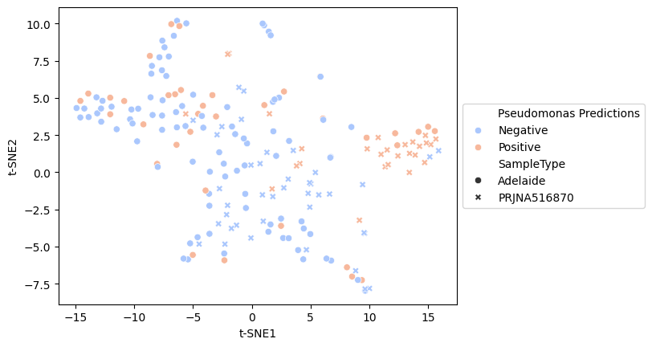

Without a ground-truth, it is hard to know what we are comparing!

PRJNA1091195
Project Title: Metagenomic data from sputa from cystic fibrosis patients.
Note: This is currently unpublished data from Scott Bell’s group at UQ, and we need to reach out to them before publishing.
The entire data set is 44 runs, and 146,735,286,366 bp (including amplicon sequences). We analysed 22 metagenomic sequence runs and predicted that 12 samples (54.5%) were likely to be Pseudomonas culture positive.
The data set is a mix of Illumina and MinION data, and I am not sure we can conclude anything without more information. We might invite Scott and team to be authors on our analysis.

PRJNA316056
Project Title: Sputum samples from cystic fibrosis patients’ metagenomes
The entire data set consists of 12 runs, totalling 36,012,000,000 bp. We analysed all 12 metagenomic sequence runs and predicted that six samples (50.0%) were likely to be Pseudomonas culture positive.

The work has not been published yet. Contact Giovanni Bacci at the University of Florence, and the outcomes are limited again. These seem to separate clearly between samples:

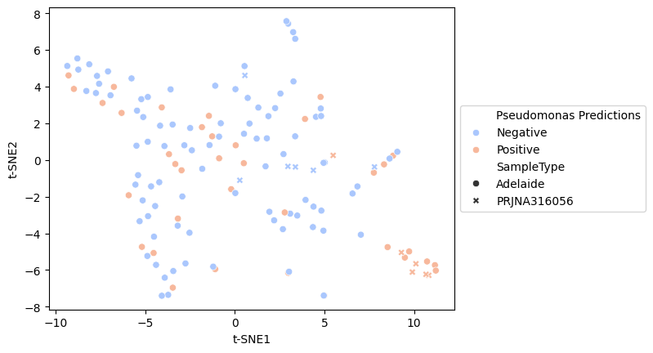
Fig. t-SNE of all the analysed sequence data coloured by whether Pseudomonas is predicted, and shapes identify different samples.

References
Agudelo-Romero, Patricia, Jose A. Caparros-Martin, Abhinav Sharma, Montserrat Saladié, Peter D. Sly, Stephen M. Stick, Fergal O Gara, and COMBAT study group. 2024. “A Near-Complete Genome of the Uncultured Staphylococcus Aureus Phage COMBAT-CF_PAR1 Isolated from the Lungs of an Infant with Cystic Fibrosis.” Microbiology Resource Announcements 13 (12): e0104724.
Agudelo-Romero, Patricia, Jose A. Caparros-Martin, Abhinav Sharma, Montserrat Saladié, Peter D. Sly, Stephen M. Stick, Fergal O’Gara, and COMBAT study group. 2025. “Virome Assembly Reveals Draft Genomes of Native Pseudomonas Phages Isolated from a Paediatric Bronchoalveolar Lavage Sample.” Microbiology Resource Announcements 14 (2): e0103024.
Almeida, Otávio Guilherme Gonçalves de, Carolina Paulino da Costa Capizzani, Ludmilla Tonani, Patrícia Helena Grizante Barião, Anderson Ferreira da Cunha, Elaine Cristina Pereira De Martinis, Lidia Alice Gomes Monteiro Marin Torres, and Marcia Regina von Zeska Kress. 2020. “The Lung Microbiome of Three Young Brazilian Patients with Cystic Fibrosis Colonized by Fungi.” Frontiers in Cellular and Infection Microbiology 10 (November): 598938.
Armbruster, Catherine R., Yasmin K. Hilliam, Anna C. Zemke, Samar Atteih, Christopher W. Marshall, John Moore, Junu Koirala, et al. 2024. “Persistence and Evolution of Pseudomonas Aeruginosa Following Initiation of Highly Effective Modulator Therapy in Cystic Fibrosis.” MBio, April, e0051924.
Cobián Güemes, Ana Georgina, Yan Wei Lim, Robert A. Quinn, Douglas J. Conrad, Sean Benler, Heather Maughan, Rob Edwards, et al. 2019. “Cystic Fibrosis Rapid Response: Translating Multi-Omics Data into Clinically Relevant Information.” MBio 10 (2). https://doi.org/10.1128/mBio.00431-19.
Dmitrijeva, Marija, Christian R. Kahlert, Rounak Feigelman, Rebekka L. Kleiner, Oliver Nolte, Werner C. Albrich, Florent Baty, and Christian von Mering. 2021. “Strain-Resolved Dynamics of the Lung Microbiome in Patients with Cystic Fibrosis.” MBio 12 (2). https://doi.org/10.1128/mBio.02863-20.
Edwards, Rob. 2025. Linsalrob/Atavide_lite: Atta Pony. Zenodo. https://doi.org/10.5281/ZENODO.15356766.
Feigelman, Rounak, Christian R. Kahlert, Florent Baty, Frank Rassouli, Rebekka L. Kleiner, Philipp Kohler, Martin H. Brutsche, and Christian von Mering. 2017. “Sputum DNA Sequencing in Cystic Fibrosis: Non-Invasive Access to the Lung Microbiome and to Pathogen Details.” Microbiome 5 (1): 20.
Felton, Erin, Aszia Burrell, Hollis Chaney, Iman Sami, Anastassios C. Koumbourlis, Robert J. Freishtat, Keith A. Crandall, and Andrea Hahn. 2021. “Inflammation in Children with Cystic Fibrosis: Contribution of Bacterial Production of Long-Chain Fatty Acids.” Pediatric Research 90 (1): 99–108.
Ghuneim, Lydia-Ann J., Ruma Raghuvanshi, Kerri A. Neugebauer, Douglas V. Guzior, Martin H. Christian, Bella Schena, Jeremiah M. Feiner, et al. 2022. “Complex and Unexpected Outcomes of Antibiotic Therapy against a Polymicrobial Infection.” The ISME Journal 16 (9): 2065–75.
Hahn, Andrea, Aszia Burrell, Hollis Chaney, Iman Sami, Anastassios C. Koumbourlis, Robert J. Freishtat, Keith A. Crandall, and Edith T. Zemanick. 2023. “Therapeutic Beta-Lactam Dosages and Broad-Spectrum Antibiotics Are Associated with Reductions in Microbial Richness and Diversity in Persons with Cystic Fibrosis.” Scientific Reports 13 (1): 1217.
Hahn, Andrea, Aszia Burrell, Hollis Chaney, Iman Sami, Anastassios C. Koumbourlis, Robert J. Freishtat, Edith T. Zemanick, Stan Louie, and Keith A. Crandall. 2021. “Importance of Beta-Lactam Pharmacokinetics and Pharmacodynamics on the Recovery of Microbial Diversity in the Airway of Persons with Cystic Fibrosis.” Journal of Investigative Medicine: The Official Publication of the American Federation for Clinical Research 69 (7): 1350–59.
Hilliam, Yasmin, Catherine R. Armbruster, Glenn J. Rapsinski, Christopher W. Marshall, John Moore, Junu Koirala, Leah Krainz, et al. 2024. “Cystic Fibrosis Pathogens Persist in the Upper Respiratory Tract Following Initiation of Elexacaftor/Tezacaftor/Ivacaftor Therapy.” Microbiology Spectrum 12 (8): e0078724.
Inam, Zaina, Erin Felton, Aszia Burrell, Hollis Chaney, Iman Sami, Anastassios C. Koumbourlis, Robert J. Freishtat, Edith T. Zemanick, Keith A. Crandall, and Andrea Hahn. 2022. “Impact of Antibiotics on the Lung Microbiome and Lung Function in Children with Cystic Fibrosis 1 Year after Hospitalization for an Initial Pulmonary Exacerbation.” Open Forum Infectious Diseases 9 (9): ofac466.
Lim, Yan Wei, Robert Schmieder, Matthew Haynes, Dana Willner, Mike Furlan, Merry Youle, Katelynn Abbott, et al. 2013. “Metagenomics and Metatranscriptomics: Windows on CF-Associated Viral and Microbial Communities.” Journal of Cystic Fibrosis: Official Journal of the European Cystic Fibrosis Society 12 (2): 154–64.
Mirhakkak, Mohammad H., Xiuqiang Chen, Yueqiong Ni, Thorsten Heinekamp, Tongta Sae-Ong, Lin-Lin Xu, Oliver Kurzai, et al. 2023. “Genome-Scale Metabolic Modeling of Aspergillus Fumigatus Strains Reveals Growth Dependencies on the Lung Microbiome.” Nature Communications 14 (1): 4369.
Mostacci, Nadja, Tsering Monika Wüthrich, Léa Siegwald, Silas Kieser, Ruth Steinberg, Olga Sakwinska, Philipp Latzin, Insa Korten, and Markus Hilty. 2023. “Informed Interpretation of Metagenomic Data by StrainPhlAn Enables Strain Retention Analyses of the Upper Airway Microbiome.” MSystems, November, e0072423.
Motta, Heryk, Júlia Catarina Vieira Reuwsaat, Fernanda Cortez Lopes, Graciele Viezzer, Fabiana Caroline Zempulski Volpato, Afonso Luís Barth, Paulo de Tarso Roth Dalcin, Charley Christian Staats, Marilene Henning Vainstein, and Lívia Kmetzsch. 2024. “Comparative Microbiome Analysis in Cystic Fibrosis and Non-Cystic Fibrosis Bronchiectasis.” Respiratory Research 25 (1): 211.
Nelson, Maria T., Christopher E. Pope, Robyn L. Marsh, Daniel J. Wolter, Eli J. Weiss, Kyle R. Hager, Anh T. Vo, et al. 2019. “Human and Extracellular DNA Depletion for Metagenomic Analysis of Complex Clinical Infection Samples Yields Optimized Viable Microbiome Profiles.” Cell Reports 26 (8): 2227-2240.e5.
Pallenberg, Sophia T., Marie-Madlen Pust, Ilona Rosenboom, Gesine Hansen, Lutz Wiehlmann, Anna-Maria Dittrich, and Burkhard Tümmler. 2022. “Impact of Elexacaftor/Tezacaftor/Ivacaftor Therapy on the Cystic Fibrosis Airway Microbial Metagenome.” Microbiology Spectrum 10 (5): e0145422.
Sommer, Lea M., Rasmus L. Marvig, Adela Luján, Anna Koza, Tacjana Pressler, Søren Molin, and Helle K. Johansen. 2016. “Is Genotyping of Single Isolates Sufficient for Population Structure Analysis of Pseudomonas Aeruginosa in Cystic Fibrosis Airways?” BMC Genomics 17 (1): 589.
Steinberg, Ruth, Alexander Moeller, Amanda Gisler, Nadja Mostacci, Markus Hilty, and Jakob Usemann. 2025. “Longitudinal Effects of Elexacaftor/Tezacaftor/Ivacaftor on the Oropharyngeal Metagenome in Adolescents with Cystic Fibrosis.” Journal of Cystic Fibrosis: Official Journal of the European Cystic Fibrosis Society 24 (3): 562–70.
Weimann, Aaron, Adam M. Dinan, Christopher Ruis, Audrey Bernut, Stéphane Pont, Karen Brown, Judy Ryan, et al. 2024. “Evolution and Host-Specific Adaptation of Pseudomonas Aeruginosa.” Science (New York, N.Y.) 385 (6704): eadi0908.
Woodcroft, Ben J., Mitchell Cunningham, Jason D. Gans, Benjamin B. Bolduc, and Suzanne B. Hodgkins. 2024. Kingfisher: A Utility for Procurement of Public Sequencing Data (version 0.4.1). https://doi.org/10.5281/zenodo.10525085.

